Exercise: Add and Stylize Markers

Coding Exercise
Replace the icon markers we added in the previous lectures with circle markers shown in the screenshot below:
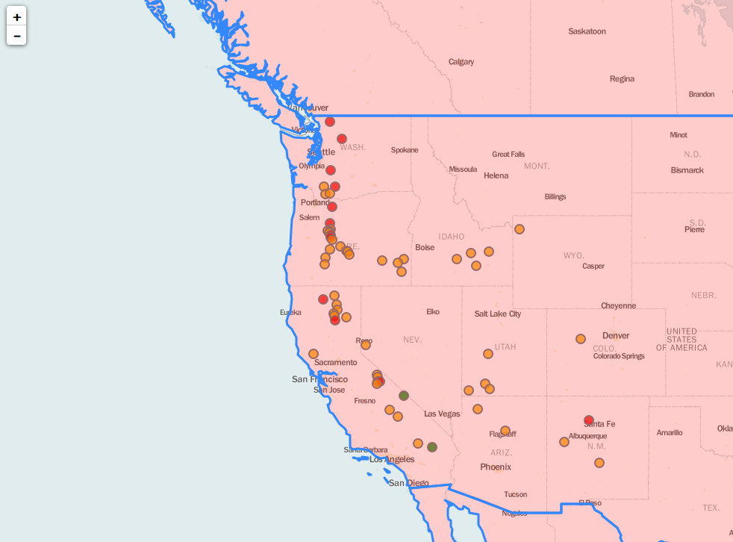

*There’s a tip in the next lecture.

